SCHOOL OF COMPUTER SCIENCE AND ARTIFICIAL INTELLIGENCE |  |  |  |  | DEPARTMENT OF COMPUTER SCIENCE ENGINEERING
Program Name: B. Tech |  |  |  | Assignment Type: Lab |  |  | Academic Year:2025-2026
Course Coordinator Name |  |  |  | Venkataramana Veeramsetty
Instructor(s) Name
  Dr. V. Venkataramana (Co-ordinator)
  Dr. T. Sampath Kumar
  Dr. Pramoda Patro
  Dr. Brij Kishor Tiwari
  Dr.J.Ravichander
  Dr. Mohammand Ali Shaik
  Dr. Anirodh Kumar
  Mr. S.Naresh Kumar
  Dr. RAJESH VELPULA
  Mr. Kundhan Kumar
  Ms. Ch.Rajitha
  Mr. M Prakash
  Mr. B.Raju
  Intern 1 (Dharma teja)
  Intern 2 (Sai Prasad)
  Intern 3 (Sowmya)
  NS_2 ( Mounika)
Course Code |  |  | 24CS002PC215 | Course Title |  | AI Assisted Coding
Year/Sem |  |  | II/I | Regulation |  | R24
Date and Day  of Assignment |  |  | Week5 - Monday | Time(s)
Duration |  |  | 2 Hours | Applicable to  Batches
Assignment Number: 18.5(Present assignment number)/24(Total number of assignments)
 | Q.No. | Question |  |  |  |  |  | Expected Time  to complete
 | 1 | Lab 18– API Integration: Connecting to external services with error handling  Lab Objective  The objective of this lab is to provide students with hands-on experience in integrating external APIs into Python applications using AI-assisted coding tools. Students will:  - Understand the fundamentals of API requests, responses, and authentication mechanisms.  - Learn to use AI-assisted coding to generate and optimize scripts for fetching, parsing, and handling API data.  - Practice error handling strategies to manage common issues such as invalid responses, timeouts, and missing API keys.  - Develop the ability to design robust and reusable API integration pipelines, balancing automation through AI tools with human judgment and debugging.  Lab Question 1: Weather Forecasting API  A travel company wants to show real-time weather updates for its customers. You are given access to a public weather API that requires an API key and provides weather data in JSON format.  - Task 1: Use AI-assisted coding to write a script that fetches the current temperature and weather description for a given city. The script should handle errors if the API key is invalid or missing.  - Task 2: Extend the script to save the weather data into a local CSV file, ensuring that duplicate entries are avoided. Implement error handling for file I/O exceptions.  Prompt:  Write a Python program for Weather Forecasting (Without API Key).The program should take a city name as user input,Use predefined (hardcoded) weather data in the code,Display the current temperature and weather description for that city,Handle errors if the city is not found,Save the data into a CSV file without duplicate entries,Include basic error handling for file operations.  Code:  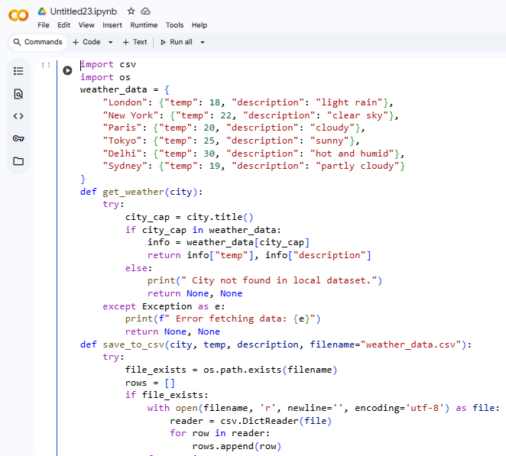  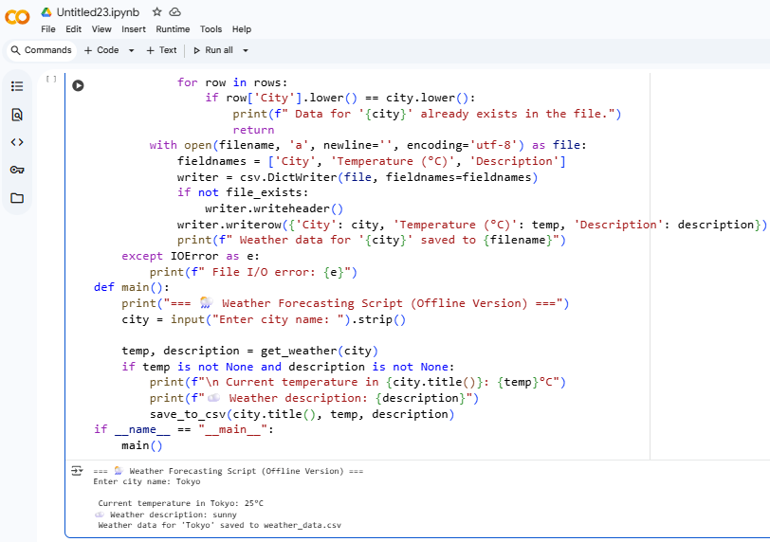  Lab Question 2: Currency Exchange Rate API  A financial startup needs a tool to convert amounts between currencies using an exchange rate API. However, the API occasionally fails due to server downtime.  - Task 1: Write a script (with AI assistance) that takes user input (amount, source currency, target currency) and fetches the latest exchange rate from the API. Include errors in handling invalid currency codes.  - Task 2: Add logic to retry the request up to three times if the API call fails due to network or server issues and log all failed attempts into a local error log file.  Prompt:  Write a Python program for Currency Exchange Rate (Without API Key).  The program should take user input for amount, source currency, and target currency,Use predefined exchange rate data in the code (no real API),Calculate and display the converted amount.,Retry up to 3 times if a simulated network error occurs,Log all failed attempts into an error_log.txt file,Handle invalid currency codes and incorrect inputs.  Code:  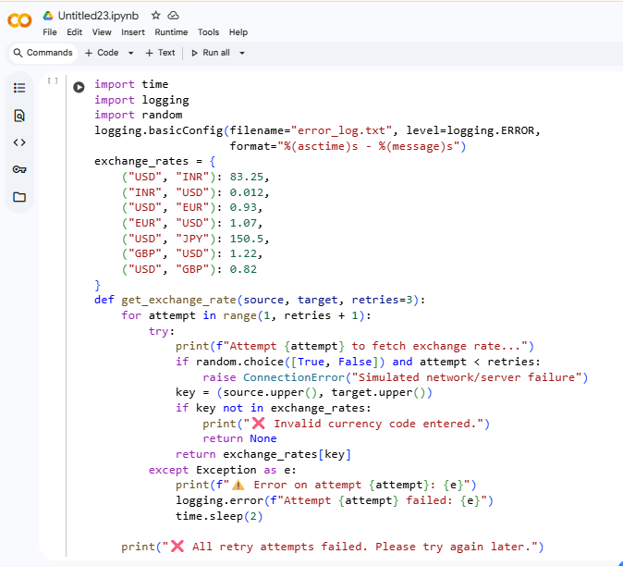  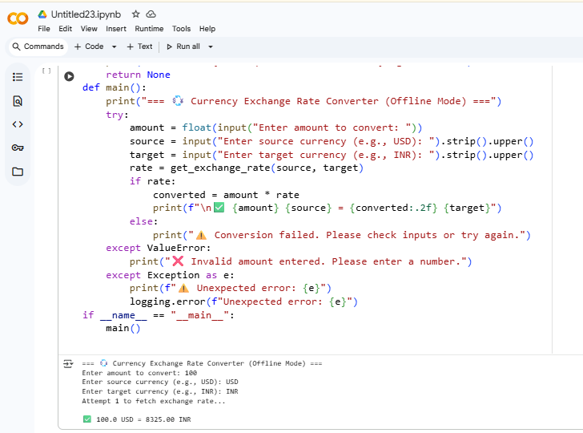  Lab Question 3: News Headlines API  A news aggregator wants to display the latest technology news headlines using a news API. Sometimes, the API responds slowly or returns incomplete data.  - Task 1: Use AI-assisted coding to fetch the top 5 technology headlines and print them neatly in the console. Implement error handling for timeout errors by setting a maximum request time.  - Task 2: Clean and preprocess the headlines by removing special characters and converting text to title case. Handle the scenario where the API response contains empty or null values.  Prompt:  Write a Python program for News Aggregator (Without API Key).  The program should take a news category (like “technology” or “sports”) as user input,Use predefined news headlines stored in the code,Simulate API delay or timeout errors,Fetch and print the top 5 headlines neatly in the console,Remove special characters and convert text to title case,Handle empty or null values safely.  Code:  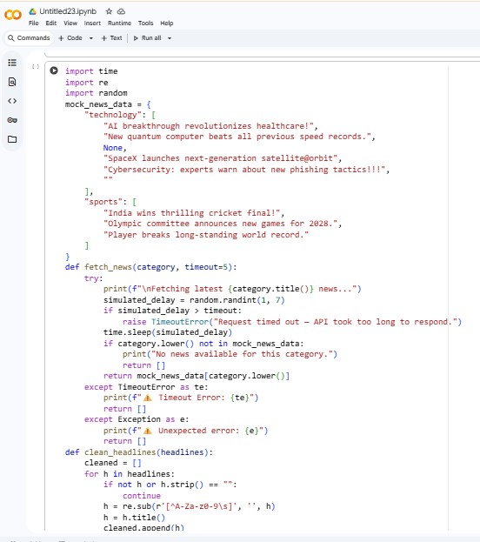  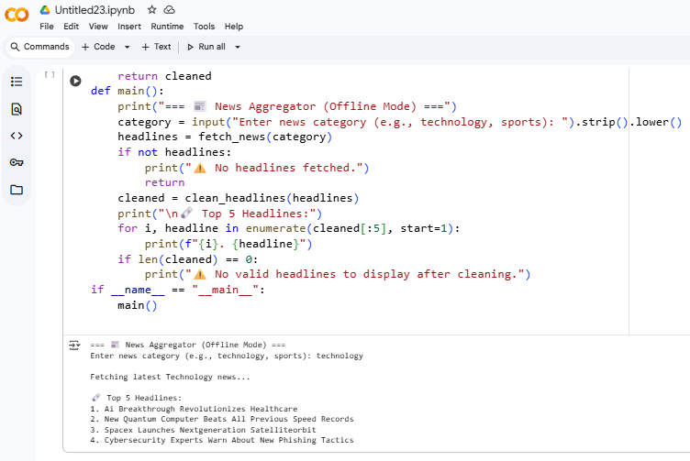 |  |  |  |  |  | Week 9 - Monday

